The graph below shows the number of tourists visiting a particular Caribbean island between 2010 and 2017.
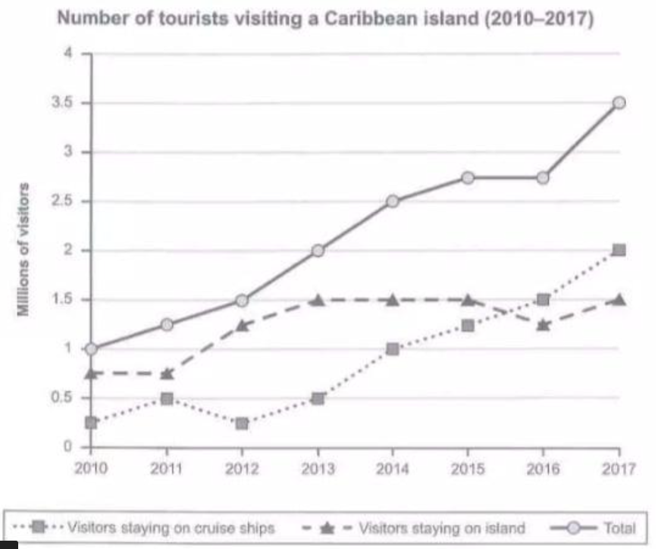
The provided graph illustrates statistical trends regarding the number of tourists who visited a Caribbean island between 2010 and 2017, including their accommodation preferences.
Overall, the number of tourists increased significantly over the period. Visitors staying on cruise ships showed a steady rise, while those staying on the island fluctuated.
A detailed observation indicates that the Caribbean Island was visited by millions of tourists each year. In 2010, approximately 0.25 million people stayed on cruise ships, while 0.75 million chose to stay on the island, making the total number of visitors 1 million. Subsequently, by 2013, the number of tourists staying on the island showed some fluctuation whereas, cruise ship stays continued to rise. Until 2015, both categories saw increases; however, the number of island visitors slightly declined thereafter. Finally, between 2016 and 2017, all categories experienced dramatic growth. The number of visitors staying on the island rose to 1.5 million, while those on cruise ships reached 2 million. This brought the total number of tourists to an impressive 3.5 million by 2017.

